**12_3_19**

**r: 4/10/20**

**r: 3/14/22, 3/28/2022**

**setup:**

**testing server : I9-16 core, 256 GB , 10 TB**

**staging: xeon-gold, 24/32 core, 512 GB- 1 TB, 100 TB.**

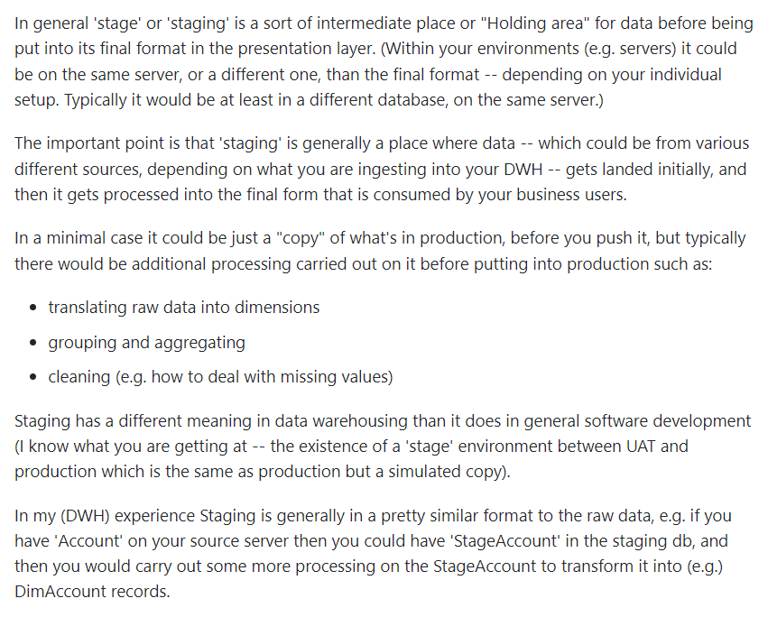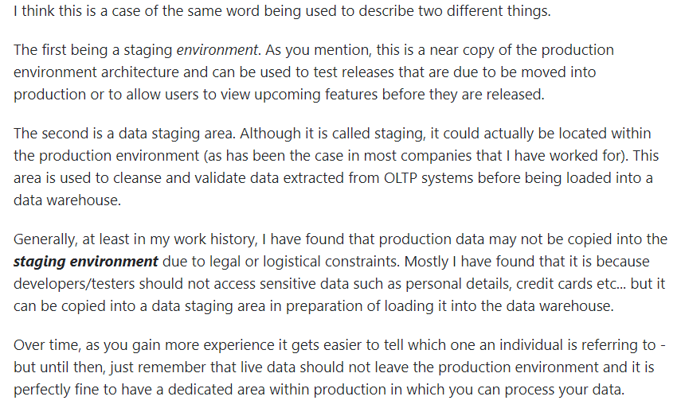

**CI/CD:**

**verify and publish SW releases by triggering automated builds & tests.**

**for every commit or at lease once a day**

**All developers should push changes to a version control, which should**

**be built and tested by Jenkins**

**Jenkins doesn't merge code or resolve code conflicts. that's git or other**

**merge tools' job.**

**Jenkins:**

**Manually create jobs with Jenkins UI**

**1) Use a web UI to input all build parameters**

**2) Segregation between Jenkins admins and developers**

**3) Difficult to backup and restore when setting is changed**

**4) When not many jobs, use UI to manager jobs is easier, but if many jobs,**

**Automate Jenkins jobs**

**1.1) write Jenkins jobs as code and save it in version control**

**1.2) Dev bundle Jenkins build instructions with their own project repository.**

**A) Jenkins "Job DSL": write code that creates and modifies Jenkins jobs automatically**

***DSL: Domain Specific Language***

**Jenkins Job DSL is a plug in**

**describe jobs using a Groovy based language.**

**B) Jenkins Pipeline (Jenkinsfile)**

**Bundle the build parameters within the project**

**put build steps in code**

**Job DSL vs Pipeline**

**1) Job DSLs creates new jobs based on the code.**

**2) Pipelines is a job type, Organization Folder**

**3) use Job DSLs to create new Pipeline jobs**

**4) Declarative Pipeline: write pipeline in Jenkins DSL**

**5) Scripted Pipeline : write the pipeline in Groovy**

**"freestyle projects" from Jenkins UI is a job type**

**Jenkins CI**

* Each developer should work in their own branch, and ideally your CI would build each developer's branch as

they commit to it... catching any build failures early during the development phase.

* After the new feature is complete or whatever, and the builds are passing for their own branch,
* then the developer would push/merge into master (triggering another build to test all the changes together)
* night Regression will run on master branch.
* Your CI should never make code changes automatically, but instead it should email/notify the offending

committer about their build-breaking changes.

* Do you work on feature branches, have the CI run automatically on those, and if the builds fail, don't merge them into master.

Option 1: build breaks, or merge breaks...change rejected and it never lands on master

Option 2: build works, jenkins pushes master and updates it

THEN, what we do is put a git commit hook in preventing EVERYONE from actually committing to master.

It works great....NO broken builds ever and NO reverting commits from master either.

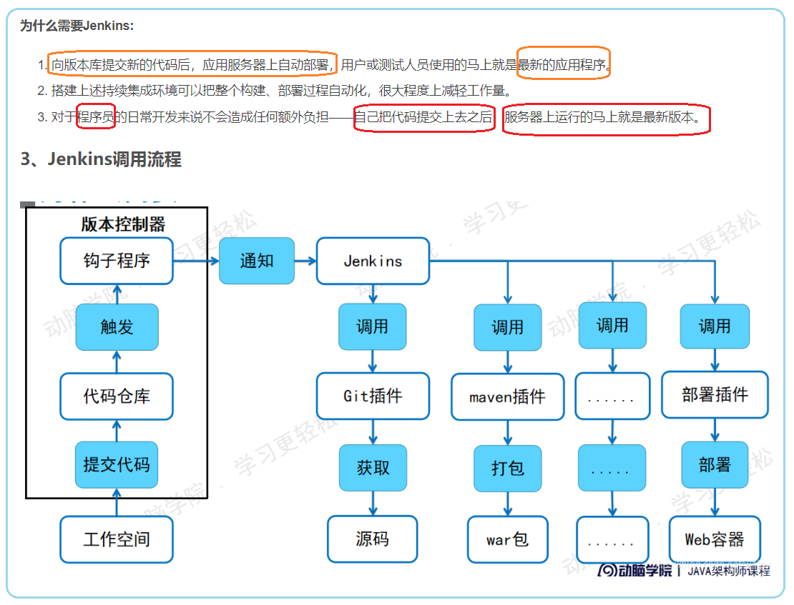

# 

# <https://blog.csdn.net/s78365126/article/details/106908686?utm_medium=distribute.pc_relevant.none-task-blog-2%7Edefault%7EBlogCommendFromMachineLearnPai2%7Edefault-3.essearch_pc_relevant&depth_1-utm_source=distribute.pc_relevant.none-task-blog-2%7Edefault%7EBlogCommendFromMachineLearnPai2%7Edefault-3.essearch_pc_relevant>

# 持续集成工具Jenkins实战详解

# <https://blog.csdn.net/m0_37923316/article/details/106623398?utm_medium=distribute.pc_relevant.none-task-blog-2%7Edefault%7EBlogCommendFromMachineLearnPai2%7Edefault-9.essearch_pc_relevant&depth_1-utm_source=distribute.pc_relevant.none-task-blog-2%7Edefault%7EBlogCommendFromMachineLearnPai2%7Edefault-9.essearch_pc_relevant>

# 持续集成工具Jenkins实战详解

# <https://blog.csdn.net/m0_37923316/article/details/106623398?utm_medium=distribute.pc_relevant.none-task-blog-2~default~baidujs_title~default-0.essearch_pc_relevant&spm=1001.2101.3001.4242>

# java web项目war包自动升级部署方案

<https://juejin.cn/post/6844903486883119117>

# Jenkins自动化部署-----持续交付

https://blog.csdn.net/xiangnan10/article/details/80332866?utm_medium=distribute.pc_relevant.none-task-blog-2%7Edefault%7EBlogCommendFromMachineLearnPai2%7Edefault-1.essearch_pc_relevant&depth_1-utm_source=distribute.pc_relevant.none-task-blog-2%7Edefault%7EBlogCommendFromMachineLearnPai2%7Edefault-1.essearch_pc_relevant

**Jenkins自动构建部署项目到远程服务器上**

<https://dominick-li.blog.csdn.net/article/details/80958761?utm_medium=distribute.pc_relevant.none-task-blog-2%7Edefault%7EBlogCommendFromBaidu%7Edefault-5.control&depth_1-utm_source=distribute.pc_relevant.none-task-blog-2%7Edefault%7EBlogCommendFromBaidu%7Edefault-5.control>

# Jenkins远程部署Linux服务器

<https://blog.csdn.net/lypgcs/article/details/104291227?utm_medium=distribute.pc_relevant.none-task-blog-2%7Edefault%7EBlogCommendFromMachineLearnPai2%7Edefault-14.essearch_pc_relevant&depth_1-utm_source=distribute.pc_relevant.none-task-blog-2%7Edefault%7EBlogCommendFromMachineLearnPai2%7Edefault-14.essearch_pc_relevant>

# jekins自动化部署（linux测试环境和生产环境）

<https://blog.csdn.net/weixin_34261415/article/details/92157304?ops_request_misc=&request_id=&biz_id=102&utm_term=jenkins%E8%87%AA%E5%8A%A8%E9%83%A8%E7%BD%B2%EF%BC%8C%20%E6%A3%80%E6%B5%8B%20%E5%92%8C%E5%8F%91%E5%B8%83&utm_medium=distribute.pc_search_result.none-task-blog-2~all~sobaiduweb~default-0-92157304.pc_search_result_control_group&spm=1018.2226.3001.4187>

# Jenkins自动化搭建测试环境

<https://blog.csdn.net/aimashi620/article/details/84061875?utm_medium=distribute.pc_relevant.none-task-blog-2%7Edefault%7EBlogCommendFromMachineLearnPai2%7Edefault-2.essearch_pc_relevant&depth_1-utm_source=distribute.pc_relevant.none-task-blog-2%7Edefault%7EBlogCommendFromMachineLearnPai2%7Edefault-2.essearch_pc_relevant>

# jenkins+selenium&python构建自动化测试平台

# <https://blog.csdn.net/weixin_43867700/article/details/88946988?utm_medium=distribute.pc_relevant.none-task-blog-2~default~baidujs_baidulandingword~default-4.essearch_pc_relevant&spm=1001.2101.3001.4242>

# jenkins自动化搭建测试环境

# <https://blog.csdn.net/u012894692/article/details/81628994?utm_medium=distribute.pc_relevant.none-task-blog-2%7Edefault%7EBlogCommendFromBaidu%7Edefault-7.essearch_pc_relevant&depth_1-utm_source=distribute.pc_relevant.none-task-blog-2%7Edefault%7EBlogCommendFromBaidu%7Edefault-7.essearch_pc_relevant>

# 如何搭建jenkins持续集成测试环境

<https://blog.csdn.net/liujingqiu/article/details/50988151?utm_medium=distribute.pc_relevant.none-task-blog-2%7Edefault%7EBlogCommendFromBaidu%7Edefault-6.essearch_pc_relevant&depth_1-utm_source=distribute.pc_relevant.none-task-blog-2%7Edefault%7EBlogCommendFromBaidu%7Edefault-6.essearch_pc_relevant>

# 测试用例接入jenkins自动运行

<https://blog.csdn.net/fanjieshanghai/article/details/49979613?utm_medium=distribute.pc_relevant.none-task-blog-2~default~baidujs_title~default-0.essearch_pc_relevant&spm=1001.2101.3001.4242>

# 最完整的自动化测试流程：Python编写执行测试用例及定时自动发送最新测试报告邮件

<https://blog.csdn.net/weixin_30293079/article/details/97686892?utm_medium=distribute.pc_relevant.none-task-blog-2%7Edefault%7EBlogCommendFromMachineLearnPai2%7Edefault-15.essearch_pc_relevant&depth_1-utm_source=distribute.pc_relevant.none-task-blog-2%7Edefault%7EBlogCommendFromMachineLearnPai2%7Edefault-15.essearch_pc_relevant>

# 最完整的自动化测试流程：Python编写执行测试用例及定时自动发送最新测试报告邮件

<https://blog.csdn.net/weixin_30293079/article/details/97686892?utm_medium=distribute.pc_relevant.none-task-blog-2%7Edefault%7EBlogCommendFromMachineLearnPai2%7Edefault-15.essearch_pc_relevant&depth_1-utm_source=distribute.pc_relevant.none-task-blog-2%7Edefault%7EBlogCommendFromMachineLearnPai2%7Edefault-15.essearch_pc_relevant>

<https://www.cnblogs.com/yufeihlf/p/5752146.html>

# Jenkins自动化无人值守运行

<https://blog.csdn.net/cyjs1988/article/details/78491659?utm_medium=distribute.pc_relevant.none-task-blog-2%7Edefault%7EBlogCommendFromMachineLearnPai2%7Edefault-12.essearch_pc_relevant&depth_1-utm_source=distribute.pc_relevant.none-task-blog-2%7Edefault%7EBlogCommendFromMachineLearnPai2%7Edefault-12.essearch_pc_relevant>

<https://blog.csdn.net/weixin_30361753/article/details/97121415?utm_medium=distribute.pc_relevant.none-task-blog-2~default~baidujs_title~default-0.essearch_pc_relevant&spm=1001.2101.3001.4242>

# 在Jenkins中配置执行远程shell命令

<https://blog.csdn.net/fireofjava/article/details/40624353?utm_medium=distribute.pc_relevant.none-task-blog-2%7Edefault%7EBlogCommendFromMachineLearnPai2%7Edefault-4.essearch_pc_relevant&depth_1-utm_source=distribute.pc_relevant.none-task-blog-2%7Edefault%7EBlogCommendFromMachineLearnPai2%7Edefault-4.essearch_pc_relevant>

# 在Jenkins中配置执行远程shell命令

<https://blog.csdn.net/weixin_30918633/article/details/95554670?utm_medium=distribute.pc_relevant.none-task-blog-2%7Edefault%7EBlogCommendFromMachineLearnPai2%7Edefault-3.essearch_pc_relevant&depth_1-utm_source=distribute.pc_relevant.none-task-blog-2%7Edefault%7EBlogCommendFromMachineLearnPai2%7Edefault-3.essearch_pc_relevant>

# Jenkins Publish over SSH，上传文件及执行命令

<https://blog.csdn.net/tragedyxd/article/details/51861526?utm_medium=distribute.pc_relevant.none-task-blog-2%7Edefault%7EBlogCommendFromBaidu%7Edefault-5.essearch_pc_relevant&depth_1-utm_source=distribute.pc_relevant.none-task-blog-2%7Edefault%7EBlogCommendFromBaidu%7Edefault-5.essearch_pc_relevant>

# 搭建完整jenkins发布环境

1. <https://blog.csdn.net/kouryoushine/article/details/90765007?ops_request_misc=%257B%2522request%255Fid%2522%253A%2522163027351116780357228390%2522%252C%2522scm%2522%253A%252220140713.130102334.pc%255Fall.%2522%257D&request_id=163027351116780357228390&biz_id=0&utm_medium=distribute.pc_search_result.none-task-blog-2~all~first_rank_ecpm_v1~rank_v29_ecpm-4-90765007.pc_search_result_control_group&utm_term=%E6%90%AD%E5%BB%BA%E5%AE%8C%E6%95%B4jenkins%E5%8F%91%E5%B8%83%E7%8E%AF%E5%A2%83&spm=1018.2226.3001.4187>
2. <https://blog.csdn.net/kouryoushine/article/details/90768650?utm_medium=distribute.pc_relevant.none-task-blog-2~default~baidujs_utm_term~default-0.essearch_pc_relevant&spm=1001.2101.3001.4242>

# [搭建完整jenkins发布环境（三）]Publish Over SSH插件使用详解及常见问题解析

1. <https://blog.csdn.net/kouryoushine/article/details/92676719?utm_medium=distribute.pc_relevant.none-task-blog-2%7Edefault%7EBlogCommendFromBaidu%7Edefault-7.essearch_pc_relevant&depth_1-utm_source=distribute.pc_relevant.none-task-blog-2%7Edefault%7EBlogCommendFromBaidu%7Edefault-7.essearch_pc_relevant>
2. <https://blog.csdn.net/kouryoushine/article/details/92983214?ops_request_misc=%257B%2522request%255Fid%2522%253A%2522163027351116780357228390%2522%252C%2522scm%2522%253A%252220140713.130102334.pc%255Fall.%2522%257D&request_id=163027351116780357228390&biz_id=0&utm_medium=distribute.pc_search_result.none-task-blog-2~all~first_rank_ecpm_v1~rank_v29_ecpm-10-92983214.pc_search_result_control_group&utm_term=%E6%90%AD%E5%BB%BA%E5%AE%8C%E6%95%B4jenkins%E5%8F%91%E5%B8%83%E7%8E%AF%E5%A2%83&spm=1018.2226.3001.4187>
3. <https://blog.csdn.net/kouryoushine/article/details/100075629?ops_request_misc=%257B%2522request%255Fid%2522%253A%2522163027351116780357228390%2522%252C%2522scm%2522%253A%252220140713.130102334.pc%255Fall.%2522%257D&request_id=163027351116780357228390&biz_id=0&utm_medium=distribute.pc_search_result.none-task-blog-2~all~first_rank_ecpm_v1~rank_v29_ecpm-6-100075629.pc_search_result_control_group&utm_term=%E6%90%AD%E5%BB%BA%E5%AE%8C%E6%95%B4jenkins%E5%8F%91%E5%B8%83%E7%8E%AF%E5%A2%83&spm=1018.2226.3001.4187>
4. <https://blog.csdn.net/kouryoushine/article/details/100081637?ops_request_misc=%257B%2522request%255Fid%2522%253A%2522163027351116780357228390%2522%252C%2522scm%2522%253A%252220140713.130102334.pc%255Fall.%2522%257D&request_id=163027351116780357228390&biz_id=0&utm_medium=distribute.pc_search_result.none-task-blog-2~all~first_rank_ecpm_v1~rank_v29_ecpm-9-100081637.pc_search_result_control_group&utm_term=%E6%90%AD%E5%BB%BA%E5%AE%8C%E6%95%B4jenkins%E5%8F%91%E5%B8%83%E7%8E%AF%E5%A2%83&spm=1018.2226.3001.4187>

# jenkins(3): jenkins执行shell命令

[**https://blog.csdn.net/weixin_30650859/article/details/98524063?utm_medium=distribute.pc_relevant.none-task-blog-2%7Edefault%7EBlogCommendFromBaidu%7Edefault-9.essearch_pc_relevant&depth_1-utm_source=distribute.pc_relevant.none-task-blog-2%7Edefault%7EBlogCommendFromBaidu%7Edefault-9.essearch_pc_relevant**](https://blog.csdn.net/weixin_30650859/article/details/98524063?utm_medium=distribute.pc_relevant.none-task-blog-2%7Edefault%7EBlogCommendFromBaidu%7Edefault-9.essearch_pc_relevant&depth_1-utm_source=distribute.pc_relevant.none-task-blog-2%7Edefault%7EBlogCommendFromBaidu%7Edefault-9.essearch_pc_relevant)

# Jenkins win10远程部署到linux服务器，执行shell后项目不启动/无效

[**https://blog.csdn.net/ypp91zr/article/details/89060043?utm_medium=distribute.pc_relevant.none-task-blog-2%7Edefault%7EBlogCommendFromBaidu%7Edefault-12.essearch_pc_relevant&depth_1-utm_source=distribute.pc_relevant.none-task-blog-2%7Edefault%7EBlogCommendFromBaidu%7Edefault-12.essearch_pc_relevant**](https://blog.csdn.net/ypp91zr/article/details/89060043?utm_medium=distribute.pc_relevant.none-task-blog-2%7Edefault%7EBlogCommendFromBaidu%7Edefault-12.essearch_pc_relevant&depth_1-utm_source=distribute.pc_relevant.none-task-blog-2%7Edefault%7EBlogCommendFromBaidu%7Edefault-12.essearch_pc_relevant)

# Jenkins触发远程Job的几种方式

[**https://blog.csdn.net/m0_37904728/article/details/82790390?utm_medium=distribute.pc_relevant.none-task-blog-2%7Edefault%7EBlogCommendFromMachineLearnPai2%7Edefault-4.essearch_pc_relevant&depth_1-utm_source=distribute.pc_relevant.none-task-blog-2%7Edefault%7EBlogCommendFromMachineLearnPai2%7Edefault-4.essearch_pc_relevant**](https://blog.csdn.net/m0_37904728/article/details/82790390?utm_medium=distribute.pc_relevant.none-task-blog-2%7Edefault%7EBlogCommendFromMachineLearnPai2%7Edefault-4.essearch_pc_relevant&depth_1-utm_source=distribute.pc_relevant.none-task-blog-2%7Edefault%7EBlogCommendFromMachineLearnPai2%7Edefault-4.essearch_pc_relevant)

# Jenkins构建触发器详解

[**https://amos-x.com/index.php/amos/archives/centos7-jenkins-trigger/**](https://amos-x.com/index.php/amos/archives/centos7-jenkins-trigger/)

# Jenkins基础入门-8-构建触发器之远程构建

[**https://blog.csdn.net/u011541946/article/details/78023374?utm_medium=distribute.pc_relevant.none-task-blog-2%7Edefault%7EBlogCommendFromBaidu%7Edefault-5.essearch_pc_relevant&depth_1-utm_source=distribute.pc_relevant.none-task-blog-2%7Edefault%7EBlogCommendFromBaidu%7Edefault-5.essearch_pc_relevant**](https://blog.csdn.net/u011541946/article/details/78023374?utm_medium=distribute.pc_relevant.none-task-blog-2%7Edefault%7EBlogCommendFromBaidu%7Edefault-5.essearch_pc_relevant&depth_1-utm_source=distribute.pc_relevant.none-task-blog-2%7Edefault%7EBlogCommendFromBaidu%7Edefault-5.essearch_pc_relevant)

# Jenkins基础入门

1. [**https://blog.csdn.net/u011541946/article/details/78003772?ops_request_misc=%257B%2522request%255Fid%2522%253A%2522163028403216780264036119%2522%252C%2522scm%2522%253A%252220140713.130102334..%2522%257D&request_id=163028403216780264036119&biz_id=0&utm_medium=distribute.pc_search_result.none-task-blog-2~all~sobaiduend~default-1-78003772.pc_search_result_control_group&utm_term=Jenkins%E5%9F%BA%E7%A1%80%E5%85%A5%E9%97%A8&spm=1018.2226.3001.4187**](https://blog.csdn.net/u011541946/article/details/78003772?ops_request_misc=%257B%2522request%255Fid%2522%253A%2522163028403216780264036119%2522%252C%2522scm%2522%253A%252220140713.130102334..%2522%257D&request_id=163028403216780264036119&biz_id=0&utm_medium=distribute.pc_search_result.none-task-blog-2~all~sobaiduend~default-1-78003772.pc_search_result_control_group&utm_term=Jenkins%E5%9F%BA%E7%A1%80%E5%85%A5%E9%97%A8&spm=1018.2226.3001.4187)

# Jenkins基础入门-2-把Jenkins服务部署在Tomcat下

[**https://blog.csdn.net/u011541946/article/details/78004622?ops_request_misc=%257B%2522request%255Fid%2522%253A%2522163028454716780255243958%2522%252C%2522scm%2522%253A%252220140713.130102334..%2522%257D&request_id=163028454716780255243958&biz_id=0&utm_medium=distribute.pc_search_result.none-task-blog-2~all~baidu_landing_v2~default-4-78004622.pc_search_result_control_group&utm_term=Jenkins%E5%9F%BA%E7%A1%80%E5%85%A5%E9%97%A8-2&spm=1018.2226.3001.4187**](https://blog.csdn.net/u011541946/article/details/78004622?ops_request_misc=%257B%2522request%255Fid%2522%253A%2522163028454716780255243958%2522%252C%2522scm%2522%253A%252220140713.130102334..%2522%257D&request_id=163028454716780255243958&biz_id=0&utm_medium=distribute.pc_search_result.none-task-blog-2~all~baidu_landing_v2~default-4-78004622.pc_search_result_control_group&utm_term=Jenkins%E5%9F%BA%E7%A1%80%E5%85%A5%E9%97%A8-2&spm=1018.2226.3001.4187)

# Jenkins基础入门-3-改变Jenkins家目录

# <https://blog.csdn.net/u011541946/article/details/78005314?ops_request_misc=%257B%2522request%255Fid%2522%253A%2522163028505016780255245787%2522%252C%2522scm%2522%253A%252220140713.130102334..%2522%257D&request_id=163028505016780255245787&biz_id=0&utm_medium=distribute.pc_search_result.none-task-blog-2~all~sobaiduend~default-1-78005314.pc_search_result_control_group&utm_term=Jenkins%E5%9F%BA%E7%A1%80%E5%85%A5%E9%97%A8-3&spm=1018.2226.3001.4187>

# Jenkins基础入门-4-如何使用Jenkins的CLI

# <https://blog.csdn.net/u011541946/article/details/78005764?ops_request_misc=%257B%2522request%255Fid%2522%253A%2522163028526416780255287630%2522%252C%2522scm%2522%253A%252220140713.130102334..%2522%257D&request_id=163028526416780255287630&biz_id=0&utm_medium=distribute.pc_search_result.none-task-blog-2~all~baidu_landing_v2~default-1-78005764.pc_search_result_control_group&utm_term=Jenkins%E5%9F%BA%E7%A1%80%E5%85%A5%E9%97%A8-4&spm=1018.2226.3001.4187>

# Jenkins基础入门-5-用户和权限管理

# <https://blog.csdn.net/u011541946/article/details/78007078?ops_request_misc=%257B%2522request%255Fid%2522%253A%2522163028536316780357262546%2522%252C%2522scm%2522%253A%252220140713.130102334.pc%255Fall.%2522%257D&request_id=163028536316780357262546&biz_id=0&utm_medium=distribute.pc_search_result.none-task-blog-2~all~first_rank_ecpm_v1~rank_v29_ecpm-18-78007078.pc_search_result_control_group&utm_term=Jenkins%E5%9F%BA%E7%A1%80%E5%85%A5%E9%97%A8-5&spm=1018.2226.3001.4187>

# Jenkins基础入门-6-简单了解系统设置

# https://blog.csdn.net/u011541946/article/details/78012874?ops_request_misc=%257B%2522request%255Fid%2522%253A%2522163028567316780271514272%2522%252C%2522scm%2522%253A%252220140713.130102334.pc%255Fall.%2522%257D&request_id=163028567316780271514272&biz_id=0&utm_medium=distribute.pc_search_result.none-task-blog-2~all~first_rank_ecpm_v1~rank_v29_ecpm-18-78012874.pc_search_result_control_group&utm_term=Jenkins%E5%9F%BA%E7%A1%80%E5%85%A5%E9%97%A8-6&spm=1018.2226.3001.4187

# Jenkins基础入门-7-创建一个Project的基本过程

[**https://blog.csdn.net/u011541946/article/details/78014179?ops_request_misc=%257B%2522request%255Fid%2522%253A%2522163029119916780265462009%2522%252C%2522scm%2522%253A%252220140713.130102334.pc%255Fall.%2522%257D&request_id=163029119916780265462009&biz_id=0&utm_medium=distribute.pc_search_result.none-task-blog-2~all~first_rank_ecpm_v1~rank_v29_ecpm-18-78014179.pc_search_result_control_group&utm_term=Jenkins%E5%9F%BA%E7%A1%80%E5%85%A5%E9%97%A8-7&spm=1018.2226.3001.4187**](https://blog.csdn.net/u011541946/article/details/78014179?ops_request_misc=%257B%2522request%255Fid%2522%253A%2522163029119916780265462009%2522%252C%2522scm%2522%253A%252220140713.130102334.pc%255Fall.%2522%257D&request_id=163029119916780265462009&biz_id=0&utm_medium=distribute.pc_search_result.none-task-blog-2~all~first_rank_ecpm_v1~rank_v29_ecpm-18-78014179.pc_search_result_control_group&utm_term=Jenkins%E5%9F%BA%E7%A1%80%E5%85%A5%E9%97%A8-7&spm=1018.2226.3001.4187)

# 

# Jenkins基础入门-8-构建触发器之远程构建

[**https://blog.csdn.net/u011541946/article/details/78023374?ops_request_misc=%257B%2522request%255Fid%2522%253A%2522163029119916780265462009%2522%252C%2522scm%2522%253A%252220140713.130102334.pc%255Fall.%2522%257D&request_id=163029119916780265462009&biz_id=0&utm_medium=distribute.pc_search_result.none-task-blog-2~all~first_rank_ecpm_v1~rank_v29_ecpm-26-78023374.pc_search_result_control_group&utm_term=Jenkins%E5%9F%BA%E7%A1%80%E5%85%A5%E9%97%A8-7&spm=1018.2226.3001.4187**](https://blog.csdn.net/u011541946/article/details/78023374?ops_request_misc=%257B%2522request%255Fid%2522%253A%2522163029119916780265462009%2522%252C%2522scm%2522%253A%252220140713.130102334.pc%255Fall.%2522%257D&request_id=163029119916780265462009&biz_id=0&utm_medium=distribute.pc_search_result.none-task-blog-2~all~first_rank_ecpm_v1~rank_v29_ecpm-26-78023374.pc_search_result_control_group&utm_term=Jenkins%E5%9F%BA%E7%A1%80%E5%85%A5%E9%97%A8-7&spm=1018.2226.3001.4187)

# 

# Jenkins基础入门-9-构建触发器之项目之间依赖关系

[**https://blog.csdn.net/u011541946/article/details/78023985?ops_request_misc=%257B%2522request%255Fid%2522%253A%2522163029126016780255239408%2522%252C%2522scm%2522%253A%252220140713.130102334.pc%255Fall.%2522%257D&request_id=163029126016780255239408&biz_id=0&utm_medium=distribute.pc_search_result.none-task-blog-2~all~first_rank_ecpm_v1~rank_v29_ecpm-7-78023985.pc_search_result_control_group&utm_term=Jenkins%E5%9F%BA%E7%A1%80%E5%85%A5%E9%97%A8-7&spm=1018.2226.3001.4187**](https://blog.csdn.net/u011541946/article/details/78023985?ops_request_misc=%257B%2522request%255Fid%2522%253A%2522163029126016780255239408%2522%252C%2522scm%2522%253A%252220140713.130102334.pc%255Fall.%2522%257D&request_id=163029126016780255239408&biz_id=0&utm_medium=distribute.pc_search_result.none-task-blog-2~all~first_rank_ecpm_v1~rank_v29_ecpm-7-78023985.pc_search_result_control_group&utm_term=Jenkins%E5%9F%BA%E7%A1%80%E5%85%A5%E9%97%A8-7&spm=1018.2226.3001.4187)

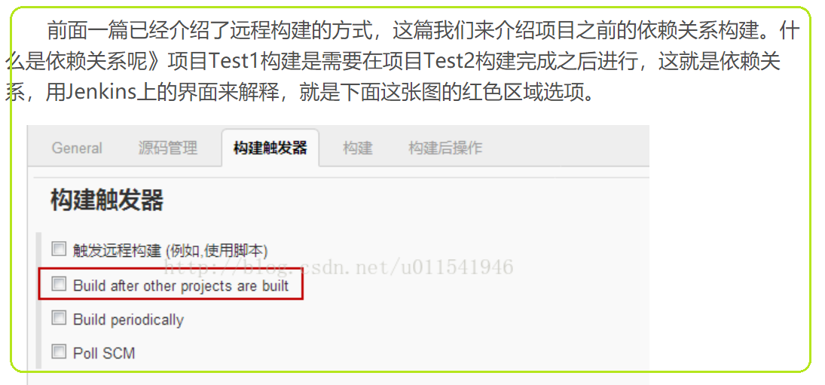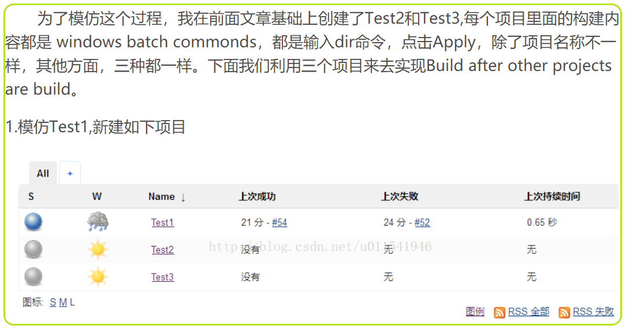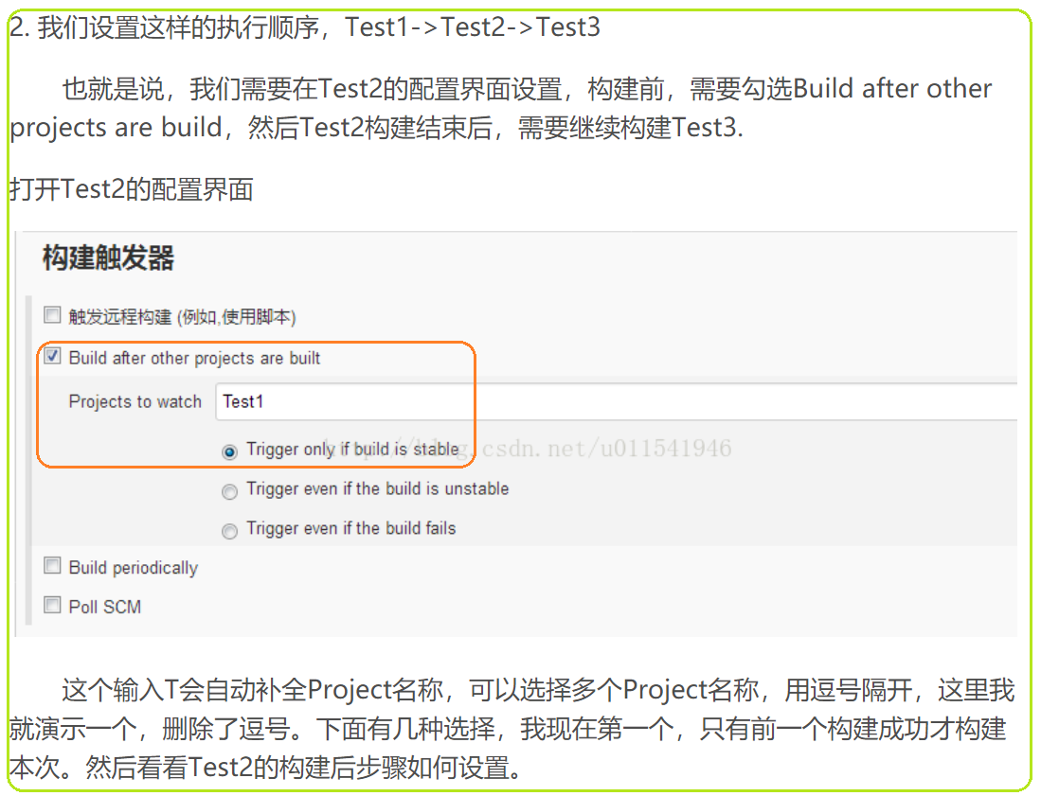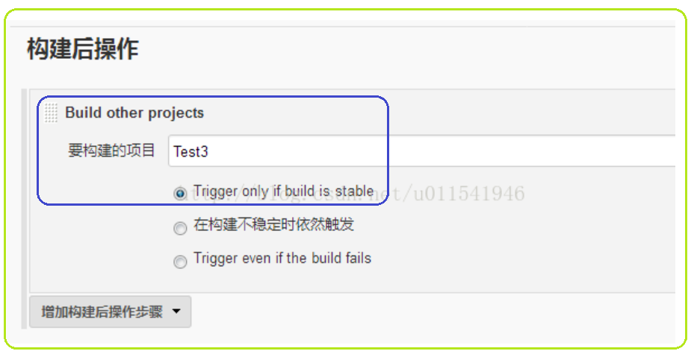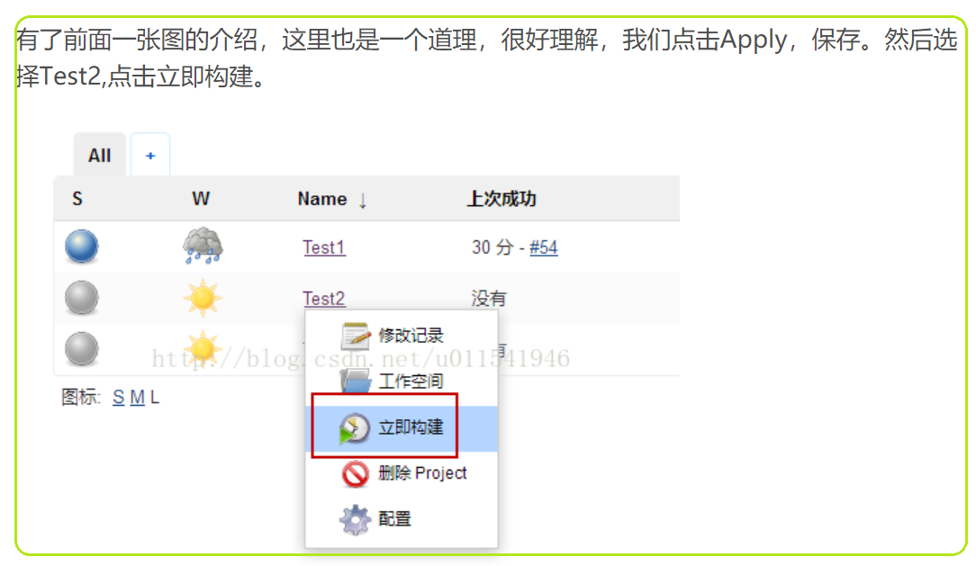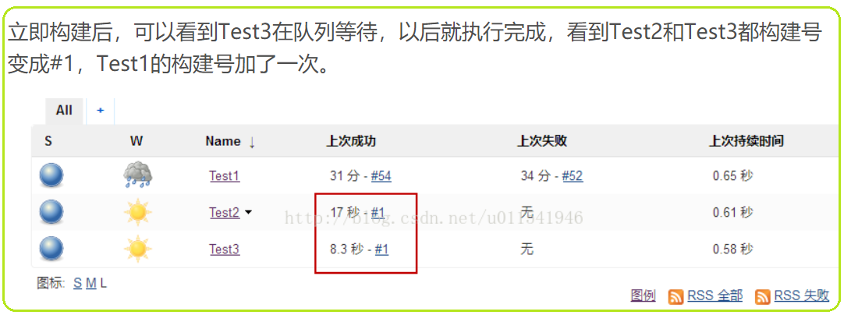

# Jenkins基础入门-10-新建一个执行java程序的Jenkins Job

[**https://blog.csdn.net/u011541946/article/details/78024348?ops_request_misc=%257B%2522request%255Fid%2522%253A%2522163029126016780255239408%2522%252C%2522scm%2522%253A%252220140713.130102334.pc%255Fall.%2522%257D&request_id=163029126016780255239408&biz_id=0&utm_medium=distribute.pc_search_result.none-task-blog-2~all~first_rank_ecpm_v1~rank_v29_ecpm-5-78024348.pc_search_result_control_group&utm_term=Jenkins%E5%9F%BA%E7%A1%80%E5%85%A5%E9%97%A8-7&spm=1018.2226.3001.4187**](https://blog.csdn.net/u011541946/article/details/78024348?ops_request_misc=%257B%2522request%255Fid%2522%253A%2522163029126016780255239408%2522%252C%2522scm%2522%253A%252220140713.130102334.pc%255Fall.%2522%257D&request_id=163029126016780255239408&biz_id=0&utm_medium=distribute.pc_search_result.none-task-blog-2~all~first_rank_ecpm_v1~rank_v29_ecpm-5-78024348.pc_search_result_control_group&utm_term=Jenkins%E5%9F%BA%E7%A1%80%E5%85%A5%E9%97%A8-7&spm=1018.2226.3001.4187)

# 

# Jenkins基础入门-11-新建一个基于git源码管理的Job

[**https://blog.csdn.net/u011541946/article/details/78045720?ops_request_misc=%257B%2522request%255Fid%2522%253A%2522163029126016780255239408%2522%252C%2522scm%2522%253A%252220140713.130102334.pc%255Fall.%2522%257D&request_id=163029126016780255239408&biz_id=0&utm_medium=distribute.pc_search_result.none-task-blog-2~all~first_rank_ecpm_v1~rank_v29_ecpm-4-78045720.pc_search_result_control_group&utm_term=Jenkins%E5%9F%BA%E7%A1%80%E5%85%A5%E9%97%A8-7&spm=1018.2226.3001.4187**](https://blog.csdn.net/u011541946/article/details/78045720?ops_request_misc=%257B%2522request%255Fid%2522%253A%2522163029126016780255239408%2522%252C%2522scm%2522%253A%252220140713.130102334.pc%255Fall.%2522%257D&request_id=163029126016780255239408&biz_id=0&utm_medium=distribute.pc_search_result.none-task-blog-2~all~first_rank_ecpm_v1~rank_v29_ecpm-4-78045720.pc_search_result_control_group&utm_term=Jenkins%E5%9F%BA%E7%A1%80%E5%85%A5%E9%97%A8-7&spm=1018.2226.3001.4187)

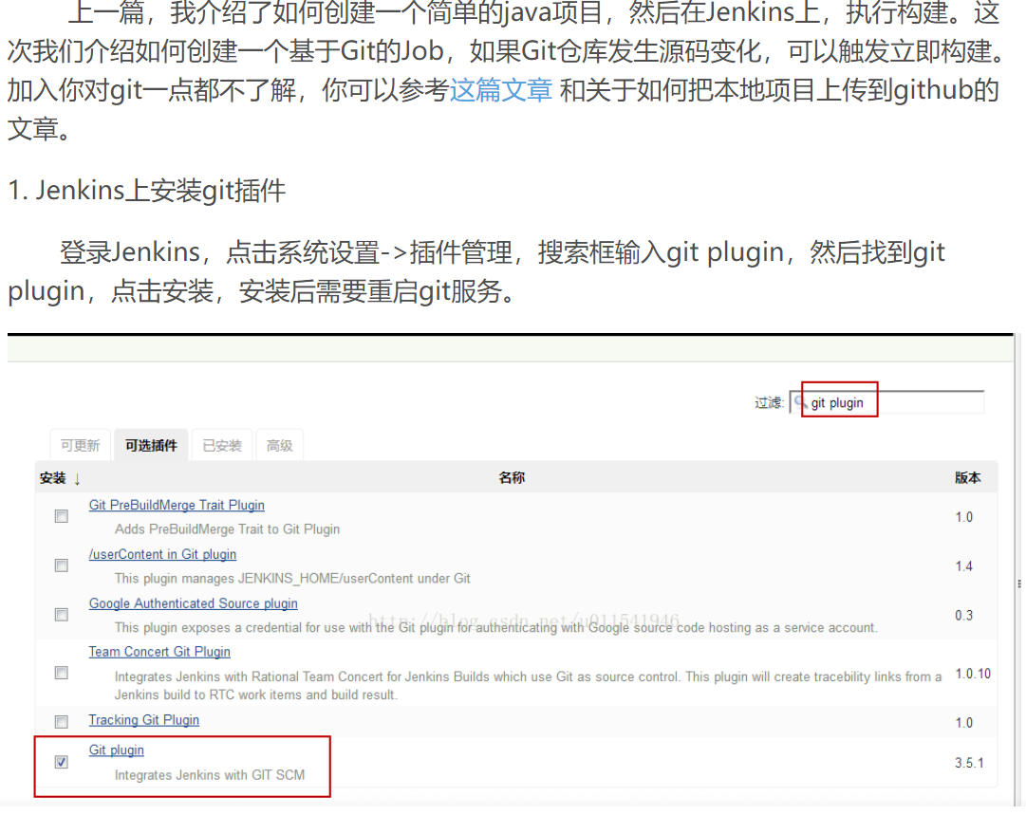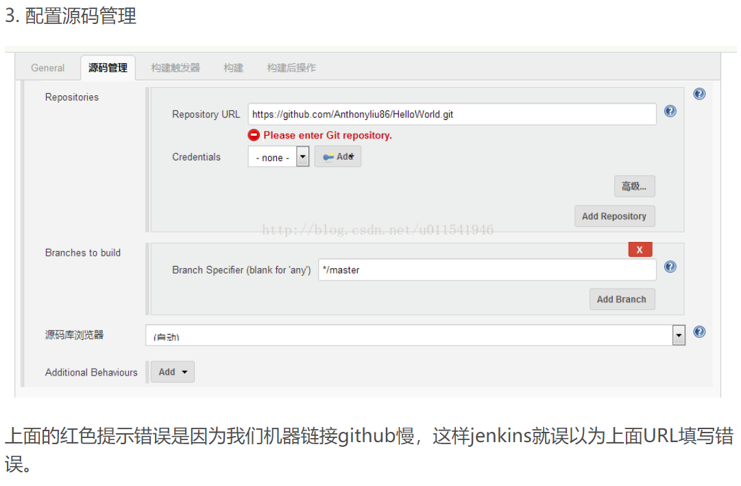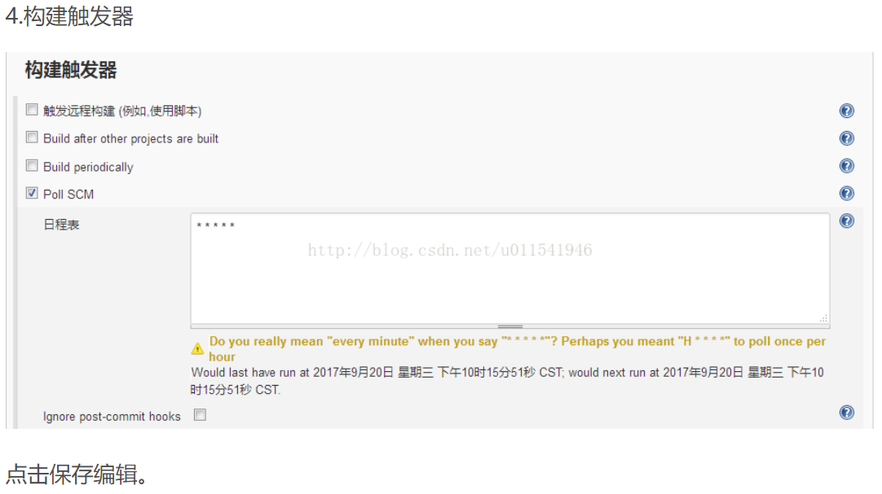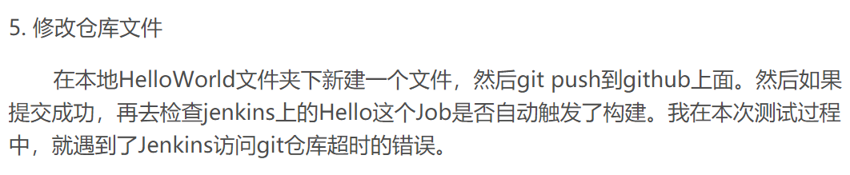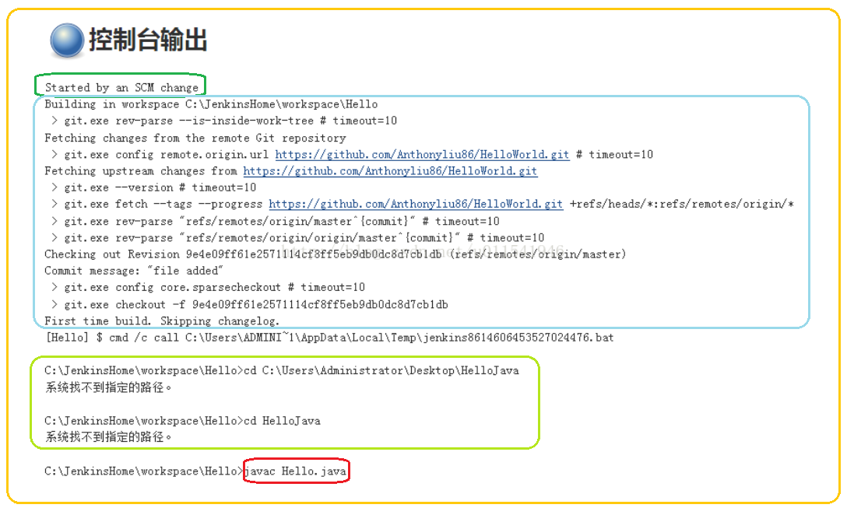

# Jenkins基础入门-12-自动化部署

[**https://blog.csdn.net/u011541946/article/details/78057530?ops_request_misc=%257B%2522request%255Fid%2522%253A%2522163029126016780255239408%2522%252C%2522scm%2522%253A%252220140713.130102334.pc%255Fall.%2522%257D&request_id=163029126016780255239408&biz_id=0&utm_medium=distribute.pc_search_result.none-task-blog-2~all~first_rank_ecpm_v1~rank_v29_ecpm-1-78057530.pc_search_result_control_group&utm_term=Jenkins%E5%9F%BA%E7%A1%80%E5%85%A5%E9%97%A8-7&spm=1018.2226.3001.4187**](https://blog.csdn.net/u011541946/article/details/78057530?ops_request_misc=%257B%2522request%255Fid%2522%253A%2522163029126016780255239408%2522%252C%2522scm%2522%253A%252220140713.130102334.pc%255Fall.%2522%257D&request_id=163029126016780255239408&biz_id=0&utm_medium=distribute.pc_search_result.none-task-blog-2~all~first_rank_ecpm_v1~rank_v29_ecpm-1-78057530.pc_search_result_control_group&utm_term=Jenkins%E5%9F%BA%E7%A1%80%E5%85%A5%E9%97%A8-7&spm=1018.2226.3001.4187)

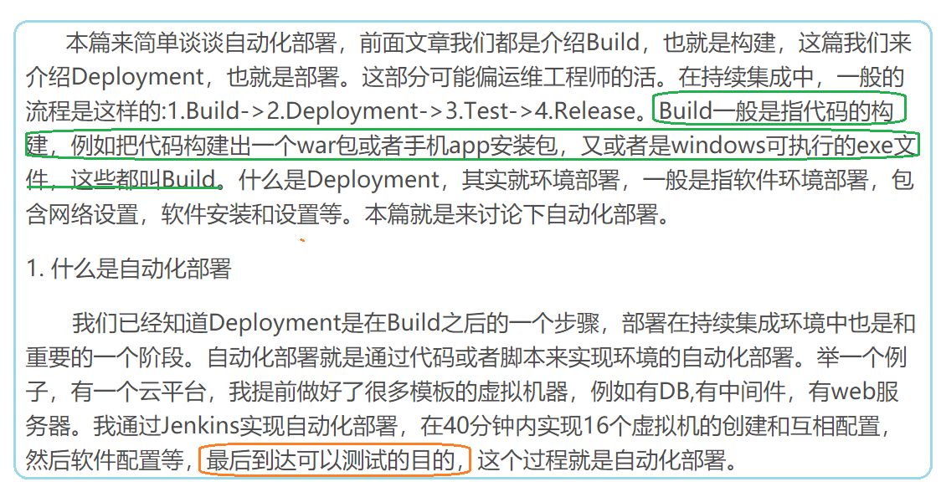

# Jenkins基础入门-13-Jenkins构建监视器-CatLight

# Jenkins基础入门-15-Jenkins中的Pipeline

[**https://blog.csdn.net/u011541946/article/details/78220110?utm_medium=distribute.pc_relevant.none-task-blog-2%7Edefault%7Eessearch%7Evector-7.essearch_pc_relevant&depth_1-utm_source=distribute.pc_relevant.none-task-blog-2%7Edefault%7Eessearch%7Evector-7.essearch_pc_relevant**](https://blog.csdn.net/u011541946/article/details/78220110?utm_medium=distribute.pc_relevant.none-task-blog-2%7Edefault%7Eessearch%7Evector-7.essearch_pc_relevant&depth_1-utm_source=distribute.pc_relevant.none-task-blog-2%7Edefault%7Eessearch%7Evector-7.essearch_pc_relevant)

**-----------------------------------------------------------------------------------------------------------------------------------**

**现在，我想知道如何实现**

**Dev-code check-in -> trigger-> Jenkins-PC to build new package 🡪 send to server PC to replace old package and run 🡪 trigger test-PC download test code and start RUN.**

**How Jenkins trigger test suite to run after NEW package is deployed**.

Jenkins handle multiple jobs, how to chain the bottom four together.

1. **Job**, maven build package from new check in
2. **Job**, send the .war to remote server through ssh
3. Job, remote server starts the application with new .war
4. **Job**, trigger testing

**Jenkins job之间依赖关系配置**

<https://blog.csdn.net/aixi1895/article/details/101724935?utm_medium=distribute.pc_relevant.none-task-blog-2~default~baidujs_title~default-0.essearch_pc_relevant&spm=1001.2101.3001.4242>

# jenkins配置不同job触发构建

# jenkins插件调用job_利用Jenkins插件实现多个job并行后再触发job

# Jenkins的job如何设置不能同时（并发）构建

# Jenkins持续集成企业实战系列之Jenkins+Ansible高并发构建

<https://blog.csdn.net/sj349781478/article/details/106299812?utm_medium=distribute.pc_relevant.none-task-blog-2~default~baidujs_baidulandingword~default-0.essearch_pc_relevant&spm=1001.2101.3001.4242>

# Jenkins中各job并行后再触发job

<https://blog.csdn.net/ouyanggengcheng/article/details/76150932?utm_medium=distribute.pc_relevant.none-task-blog-2%7Edefault%7EBlogCommendFromMachineLearnPai2%7Edefault-2.essearch_pc_relevant&depth_1-utm_source=distribute.pc_relevant.none-task-blog-2%7Edefault%7EBlogCommendFromMachineLearnPai2%7Edefault-2.essearch_pc_relevant>

# 

# 

# jenkins实现job依赖编排

<https://blog.csdn.net/qq_19655405/article/details/105810205?utm_medium=distribute.pc_relevant.none-task-blog-2%7Edefault%7EBlogCommendFromBaidu%7Edefault-5.essearch_pc_relevant&depth_1-utm_source=distribute.pc_relevant.none-task-blog-2%7Edefault%7EBlogCommendFromBaidu%7Edefault-5.essearch_pc_relevant>

# 持续集成之Jenkins插件使用（一）- 多个job之间的串并联

<https://blog.csdn.net/wang_quan_li/article/details/51143728?utm_medium=distribute.pc_relevant.none-task-blog-2~default~baidujs_title~default-8.essearch_pc_relevant&spm=1001.2101.3001.4242>

# jenkins 多个项目之间串并联执行

<https://blog.csdn.net/sunsgne_AC/article/details/80098231?utm_medium=distribute.pc_relevant.none-task-blog-2%7Edefault%7EBlogCommendFromMachineLearnPai2%7Edefault-9.essearch_pc_relevant&depth_1-utm_source=distribute.pc_relevant.none-task-blog-2%7Edefault%7EBlogCommendFromMachineLearnPai2%7Edefault-9.essearch_pc_relevant>

# jenkins(十七)：Jenkins-pipeline(1)-基础

<https://blog.csdn.net/weixin_30273763/article/details/99580878?utm_medium=distribute.pc_relevant.none-task-blog-2%7Edefault%7EBlogCommendFromMachineLearnPai2%7Edefault-3.essearch_pc_relevant&depth_1-utm_source=distribute.pc_relevant.none-task-blog-2%7Edefault%7EBlogCommendFromMachineLearnPai2%7Edefault-3.essearch_pc_relevant>

# jenkins之-pipeline基础知识

https://blog.csdn.net/byygyy/article/details/105258816?utm_medium=distribute.pc_relevant.none-task-blog-2~default~baidujs_title~default-1.essearch_pc_relevant&spm=1001.2101.3001.4242

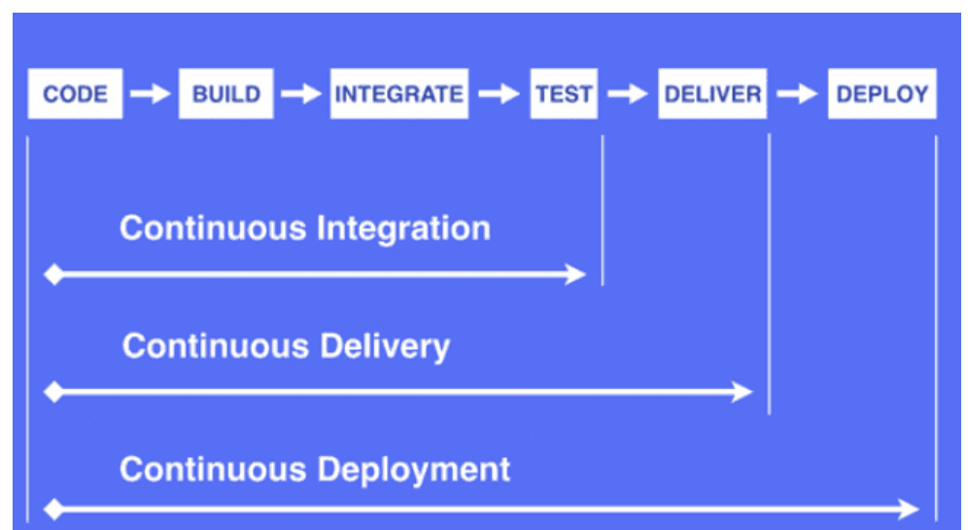

# Jenkins入门（一）

<https://blog.csdn.net/miss1181248983/article/details/82840006?utm_medium=distribute.pc_relevant.none-task-blog-2%7Edefault%7EBlogCommendFromBaidu%7Edefault-4.essearch_pc_relevant&depth_1-utm_source=distribute.pc_relevant.none-task-blog-2%7Edefault%7EBlogCommendFromBaidu%7Edefault-4.essearch_pc_relevant>

# Jenkins入门（二）

<https://blog.csdn.net/miss1181248983/article/details/82901692?ops_request_misc=%257B%2522request%255Fid%2522%253A%2522163030932716780269812577%2522%252C%2522scm%2522%253A%252220140713.130102334..%2522%257D&request_id=163030932716780269812577&biz_id=0&utm_medium=distribute.pc_search_result.none-task-blog-2~all~sobaiduend~default-1-82901692.pc_search_result_control_group&utm_term=Jenkins%E5%85%A5%E9%97%A8%EF%BC%88%E4%BA%8C%EF%BC%89&spm=1018.2226.3001.4187>

# Linux日常运维（一）

<https://blog.csdn.net/miss1181248983/article/details/80634490>

# jenkins+maven+svn自动部署和发布（超详细，图文并茂）

<https://blog.csdn.net/hongtaolong/article/details/83451507?utm_medium=distribute.pc_relevant.none-task-blog-2%7Edefault%7EBlogCommendFromBaidu%7Edefault-6.control&depth_1-utm_source=distribute.pc_relevant.none-task-blog-2%7Edefault%7EBlogCommendFromBaidu%7Edefault-6.control>

[**DevOps实战（一）- Jenkins安装集成和案例分析**](https://blog.csdn.net/hemin1003/article/details/90371702?ops_request_misc=&request_id=&biz_id=102&utm_term=devops%20jenkins&utm_medium=distribute.pc_search_result.none-task-blog-2~all~sobaiduweb~default-6-90371702.pc_search_result_control_group)

<https://blog.csdn.net/hemin1003/article/details/90371702?ops_request_misc=&request_id=&biz_id=102&utm_term=devops%20jenkins&utm_medium=distribute.pc_search_result.none-task-blog-2~all~sobaiduweb~default-6-90371702.pc_search_result_control_group&spm=1018.2226.3001.4187>

# Jenkins实践——创建Pipeline的两种方式

<https://blog.csdn.net/qihoo_tech/article/details/106435478?ops_request_misc=&request_id=&biz_id=102&utm_term=jenkins%20pipeline&utm_medium=distribute.pc_search_result.none-task-blog-2~all~sobaiduweb~default-5-106435478.nonecase&spm=1018.2226.3001.4187>

